Instructions to Change over to new 2CB5-S Filter

Our original filter (the white plastic tube) has been discontinued. The new 2CB5-S filter has been provided with purchase orders since early 2025. Customers were able to replace the original white filter (which was recommended every 6 months) up to early 2026, but are no longer available. The new 2CB5-S filter will last 12 months but need the mounting bracket to be changed. The steps below guide a customer or plumber to do this.

After this has been changed over only the cartridge needs replacement once a year in line with warranty requirements.

Steps to Change Over Peppy Taps
Old white plastic filter to new Pentair Everpure 2CB5-S filter including mounting bracket:

- Power off the boiler (and the chiller if you have one).
- Turn off your water (cold mains stopcock under the sink)
- Have a towel ready under your filter
- Twist off the old white cartridge (little water may come out)
- Unscrew the current white plastic mounting bracket from the cupboard. Careful with the flexi hoses.
- Disconnect the two 6mm flexi hoses one at a time. Standard plumbing push fitting. Push in the ring around the connection with your fingernails and it will allow you to gently pull the flexi hose out. May need to remove the blue u-shaped lock piece before pushing in the ring if your connection had these added (often not).
- Push the same 6mm flexi hoses into the new silver/black mounting bracket. The flexi hose will go in about an inch. When you try to tug on it gently it will not come out.
- Screw into the cabinet the new silver/black mounting bracket. It is wider than the previous one.
- Push up into the mounting bracket slightly and twist on the new cartridge securely
- Run the filtered chilled/ambient water for 5 mins to flush through the new cartridge. If Signature (electronic) tap, run two cycles of the blue sensor.
- To reset the filter flashing symbol on the boiler, hold the bottom temp sensor until it beeps (approx. 5 secs)
- Power on the boiler and chiller units again
- Record the date and to change within 12 months.

To reset the 6-month FILTER timer on the boiler:
- Power off the boiler by holding your thumb on the top sensor
- Hold the bottom temperature sensor with your thumb until it beeps – approx. 4-5 secs
- Power on the boiler by holding your thumb on the top sensor
The filter indicator will have stopped flashing.

Overleaf for system diagram examples to understand where the filter is in the system set up
Diagrams also available in your installation manual or our Product Spec document on the website.

Trouble Shooting please ring below:
Business hours call 03 9122 0716
After hours call 0475 018 753
Flagship Boiling Ambient
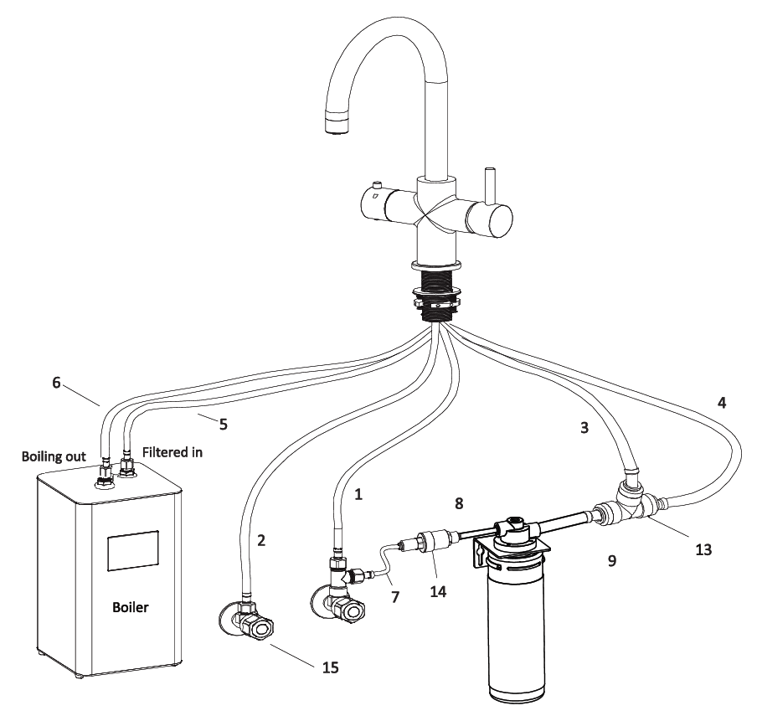

Signature Pullout Boling Chilled
